Student Name: Sahil Hans UID: 25MCI10088
Branch: M.C.A(A.l & M.L) Section/Group: MAM-1 A
Semester: Second Sem Performance:12/01/2026
Subject Name: TECHINCAL SKILLS Subject Code:

WORKSHEET 10

Aim:
To demonstrate transactions, savepoints, and rollback operations in PostgreSQL.

Tools Used:
PostgreSQL

Theory:
A transaction is a sequence of operations performed as a single logical unit of work. PostgreSQL supports transactions using BEGIN, COMMIT, and ROLLBACK. Savepoints allow partial rollback within a transaction.

CODE:
Step 1: Create Table
CREATE TABLE Payroll (
emp_id INT PRIMARY KEY,
emp_name VARCHAR(50),
salary DECIMAL(10,2) CHECK (salary > 0)
);
Step 2: Insert Initial Data
INSERT INTO Payroll VALUES
(1, 'Amit', 30000),
(2, 'Neha', 40000),
(3, 'Ravi', 50000);

Step 3: View Initial Data
SELECT * FROM Payroll;
Output:
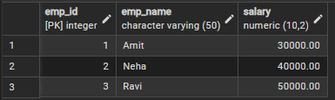

Transactin Block
BEGIN;
Step 4: Update Salary (Valid)
UPDATE Payroll
SET salary = salary + 5000
WHERE emp_id = 1;
Step 5: Savepoint
SAVEPOINT sp1;
Output: - Data till 1st checkpoint
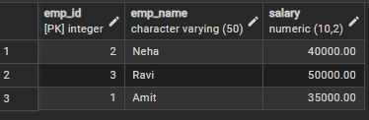

Step 6: Another Valid Update
UPDATE Payroll
SET salary = salary + 7000
WHERE emp_id = 2;
Step 7: Error Simulation
UPDATE Payroll
SET salary = -1000
WHERE emp_id = 3;

Output:
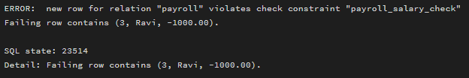

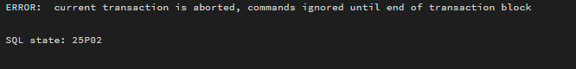
Step 8: Rollback
ROLLBACK TO sp1;
Output:
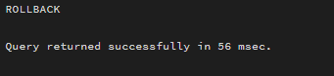

Step 9: Commit
COMMIT;
Output:
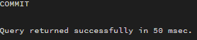
Step 10: Final Data
SELECT * FROM Payroll;
Ouput:
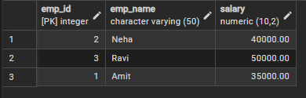

Learning Outcomes
- Understood transaction management in PostgreSQL.
- Learned how to use savepoints.
- Implemented rollback for error handling.

